# CS 340 README

## About the Project/Project Title

*This project is a web application that provides a user-friendly interface through which to sift data stored in a database that was imported through MongoDB. This application allowed you to filter through based on breed, sex, age, and rescue of the dogs/cats in the database. The full project is a Database, an API and an interactive dashboard.*

## Motivation

*The reason behind using the dashboard or program to create the dashboard is because it easy to use and is interactive so filter through data through a large database is a lot easier. The dashboard Is fairly easy to use just requires some setup prior to when creating it to make user interactivity easy and capable of finding what you are looking for. You can use dash tags to control outputs to segments and updates to any of the target inputs specified in the apps callback processes based on insruciton that was setup within the pythod module.*

## Getting Started

*In order to create a dashboard in a similar fashion you will need to start by creating a MongoDB. Youw ill then need to create a python module in which you assign your CRUD method in the form that works for you or that you understand. These two will need to be able to work together and pull from one another so you will need to create a user and password and import the documents into the module. You will then create a dashboard web application that can pull and implement from the Database and your python module in order to run your CRUD method. This table will be able to adapt to changes and react to them in real time as you click on the buttons and rows.*

## Installation

*In order to run this program you will need a couple of tools on hand. You will need jupyter notebook in order to create your python module and start your dashboard application to pull from your CRUD method. You will need python for your command line or terminal and a MongoDB.*

## Usage

*Use this space to show useful examples of how your project works and how it can be used. Be sure to include examples of your code, tests, and screenshots.*

### Code Example

*The application we created for this class will have a few important functions. We will have our radial buttons to sort data based on breed, age, and sex characteristics for all types of rescue dogs. This was wanted by Grazioso Salvare. Clicking on the radial buttons with do database queries and returns an updated data frame with the results that were inquired on. The reset button will reset all widgets back to beginning functionability so you can restart a search if need be. There is also a function that includes a map with mapping updates. The map will start with a marker where the first selected animal is currently at based on geo location. The user can select a row or multiple rows at a time the map changes the marker or adds multiple markers depending on your choices. The last function is a pie chart of the database based on the breed of the animal shown.*

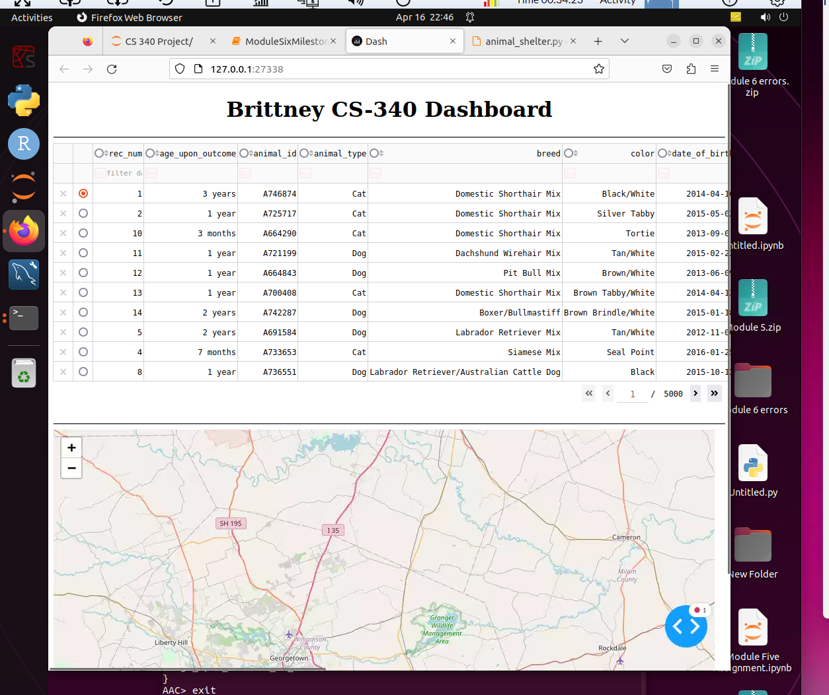

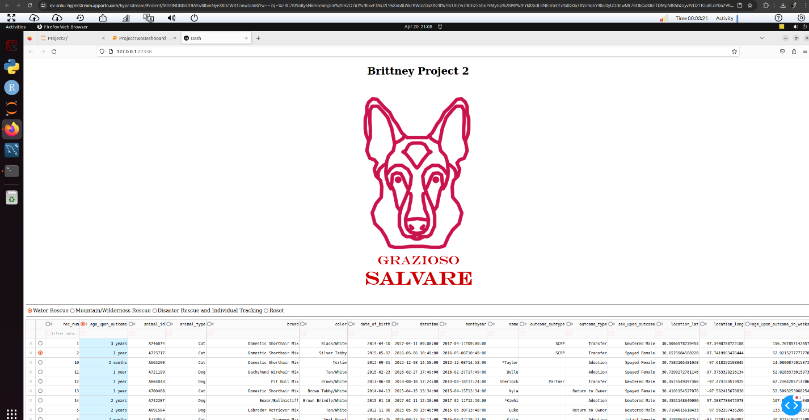

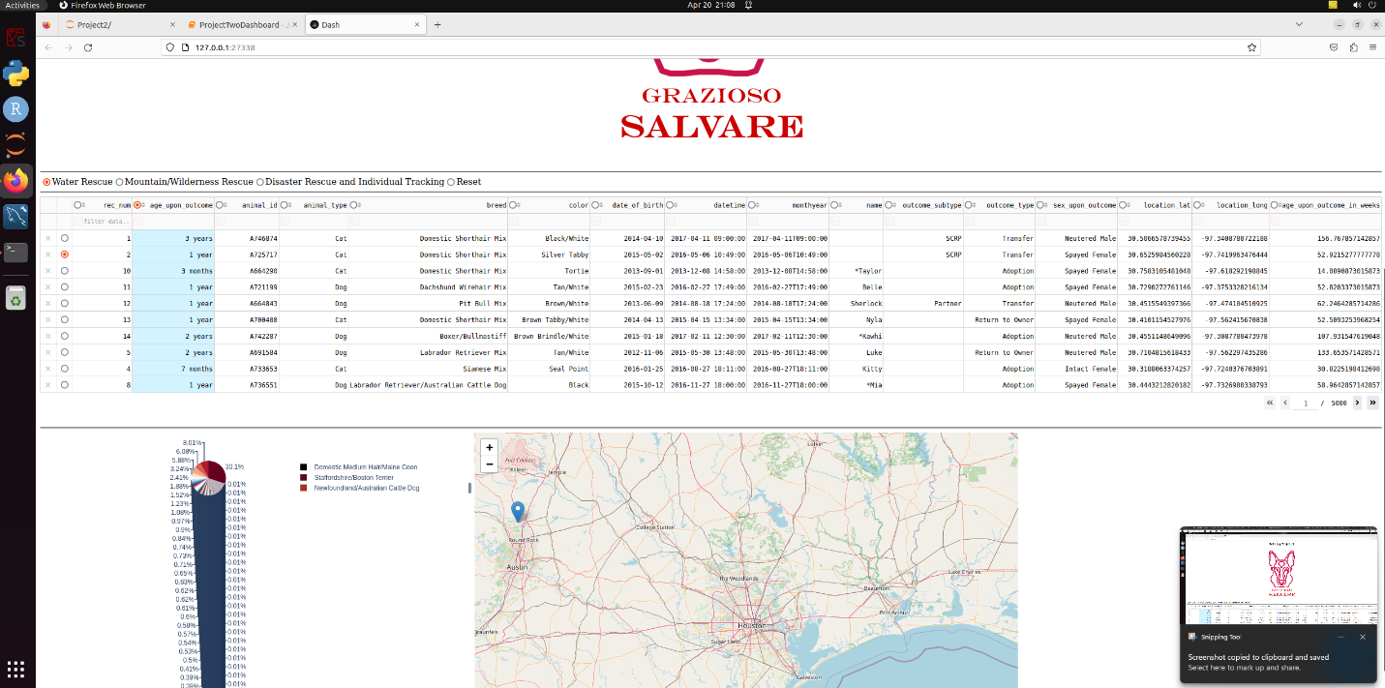

## Contact

Your name: Brittney Miller